TASK | SCREENSHOT
Add a new user “adduser” with your own name | 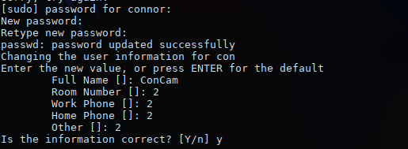
Add a password to your account: “passwd” with your own name  Use the password “toor” | 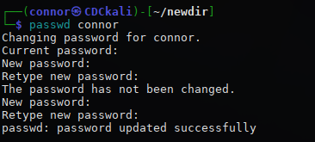
Add a new user “adduser” with your own name with the number 2 at the end | 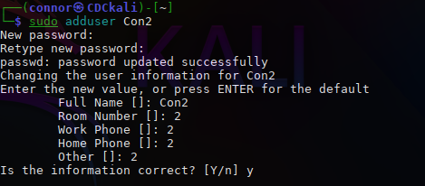
Add a password to your account: “passwd” with your own name  Use the password “toor” | 
Once created type “whoami” | 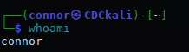
Log into the user “su - (your name)” | 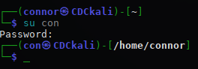
Log into the user “su - (your name2)”  Enter password | 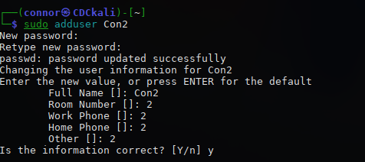
Create a directory named “mkdir newdir” | 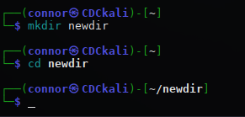
Move into the directory created “cd newdir” | 
Print working directory “pwd” | 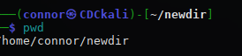
Create a directory named “mkdir newdir2” | 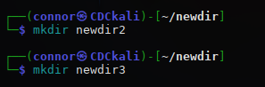
Create a directory named “mkdir newdir3” | 
Create a file in the current directory using “touch newfile1” | 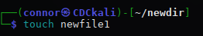
List all the files and directories in the directory you are in ls | 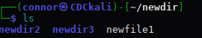
Long list all the files in the directory ls –l have a look at the permissions | 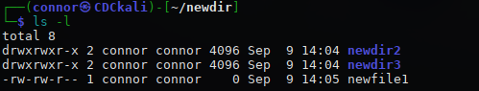
Change permissions for the file to full for user, group and other “chmod 777 newfile1” | 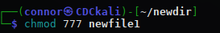
Long list all the files in the directory ls –l have a look at the permissions see how they have changed | 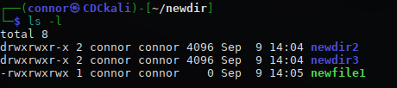
Display the calendar “cal” | 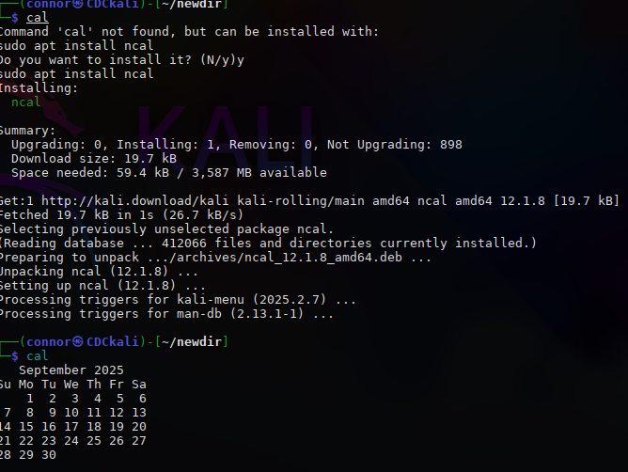
Create a file using “nano newfile” enter some text and save ctrl o ENTER ctrl x | 

Generate a list of all users currently logged in to system “whoami” | 
Review the manual page for commands. For example:  “man who”  Find out the full command to show the who command with headings | 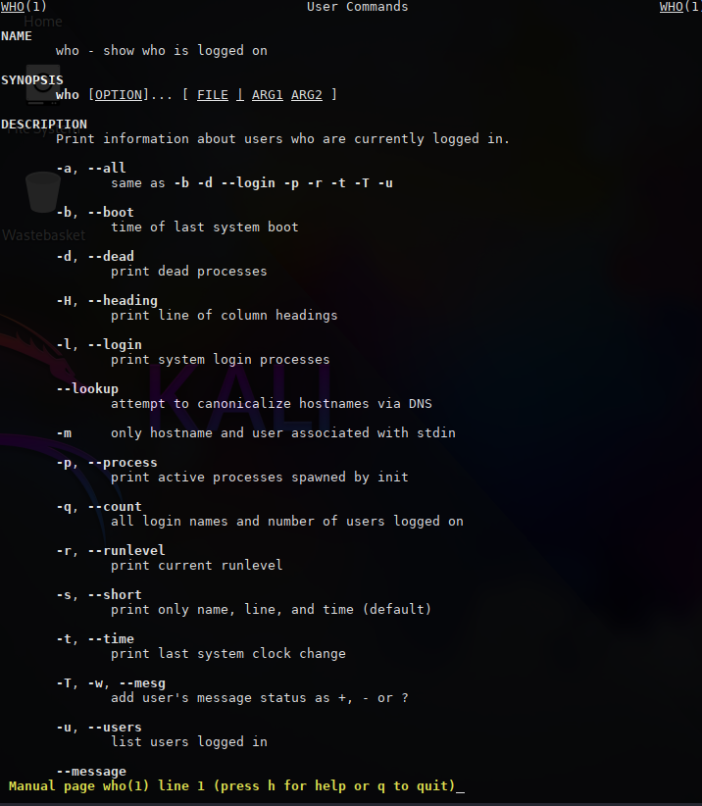
Generate a list of all users currently logged in to system with headings above each column “who –H” | 